Some  &  Any | Gebruik je als er sprake is van :  - telbare (tafels, meisjes, auto’s, paarden, etc.) zelfstandige naamwoorden  - ontelbare (suiker, regen, vlees, melk, politie, etc.) zelfstandige naamwoorden.
In het Nederlands zeggen we: nog wat, iets, enkele of wat

Some  Someone  Somebody  Something  Somewhere | - bevestigende zinnen  We've got some bottles of milk in the fridge.  - vragende zinnen in de vorm van:  - aanbieden:  Can I offer you some tea?  - om iets vragen:  Could you pass me some toast, please?  - suggestie/voorstellen:  Why don’t we get some food?
Any  Anyone  Anybody  Anything  Anywhere | - ontkennende zinnen  We haven't got any bottles of milk in the fridge.  - in de meeste vragende zinnen, of wanneer je niet weet wat het antwoord zal zijn.  Have you got any idea what this word means?  - Als er never, without, hardly in de zin staat

Some iets, wat, een paar any iets, wat, elk
Somebody iemand anybody (n)iemand
Someone iemand anyone (n)iemand
Something iets, wat anything (n)iets, wat
Somewhere ergens anywhere (n)ergens, overal
Opdracht 1
- There aren’t some / any letters for you.
- We need some / any more milk.
- She’s got some / any interesting friends.
- Are there some / any restaurants near here?
- I’m having some / any problems with my car.
- I didn’t have some / any breakfast today.
- He hasn’t done some / any work for ten years.
- I’d like some / any help.
- Could I have some / any coffee?
- There isn’t some / any milk left.
- Robin Hood gave some / any money to the poor.
- Poor people don’t have some / any money.
- Some / Any weeks ago I lost my key.
- There aren’t some / any elephants in the zoo.
- I’m going to buy some / any sandwiches.
- She doesn’t know some / any scary stories.
- I like to listen to some / any scary stories.
- We would like some / any chocolate please.
- There aren’t some / any nice boys in our class.
- Some / Any of the skiing instructors are really handsome.

Opdracht 2
- I would like some / any information about the festival Tomorrowland.
- Is there some / any news about the festival?
- We have some / any nice photos of the festival.
- Are there some / any activities at the festival?
- There will be some / any music and dance of course.
- And you can buy some / any nice souvenirs at the festival.
- Is there some / any news about the line-up?
- I hope my parents will give me some / any money for the festival.
- Because I can use some / any.
- I want to buy some / any tickets.
- Do you know if there is some / any food at the festival?
- There will be some / any security at the festival.
- When the festival is over I hope there will be some / any buses.
- We don’t have some / any transportation.
- There aren’t some / any children on the festival.

Opdracht 3
- Have you go some / any questions? Yes, I’ve got some / any questions.
- Are there some / any good films on TV? No, there aren’t some / any films at all.
- The car needs some / any oil. But I’ve just put some / any in the tank.
- How many children has he got? He hasn’t got some / any.
- This is wonderful soup. Have you got some / any more.
- Did anyone / someone buy tickets for the film? No sorry, anybody / nobody did.
- You look really hungry. Would you like any / some sandwiches?
- Wow! He is any / some guitar player.
- They aren’t sure whether there will be any / some snow tomorrow.
- Is there anything / something I can do for you? Are you sure there is nothing I can do?
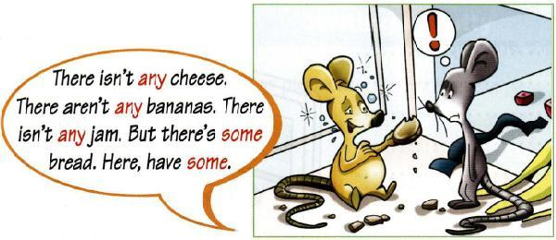

Opdracht 4 Vul in: some / any-body/one/thing/where
- Is ………………………… at home?
- I haven’t seen Puck………………………… .
- There’s ………………………… at the door.
- Can I do ………………………… to help you?
- Did you hear ………………………… about it?
- I want to tell you ………………………….
- I don’t know ………………………… who plays rugby.
- I want to live ………………………… warm.
- Has ………………………… seen my keys?
- Joyce lives in London ………………………….
- She didn’t speak to …………………………
- Did you see ………………………… there?
- Do you know ………………………… on Ibiza?
- Did you learn ………………………… new?
- I don’t know ………………………… of these people here.
- Could you please lend me ………………………… money?
- Is there ………………………… going to listen to my story?
- Bram told me ………………………… things that were new to me.
- My mum doesn’t listen to ………………………… deep house.
- My father has got ………………………… interesting books about the war.

